Student Schedule and Classroom Stepper

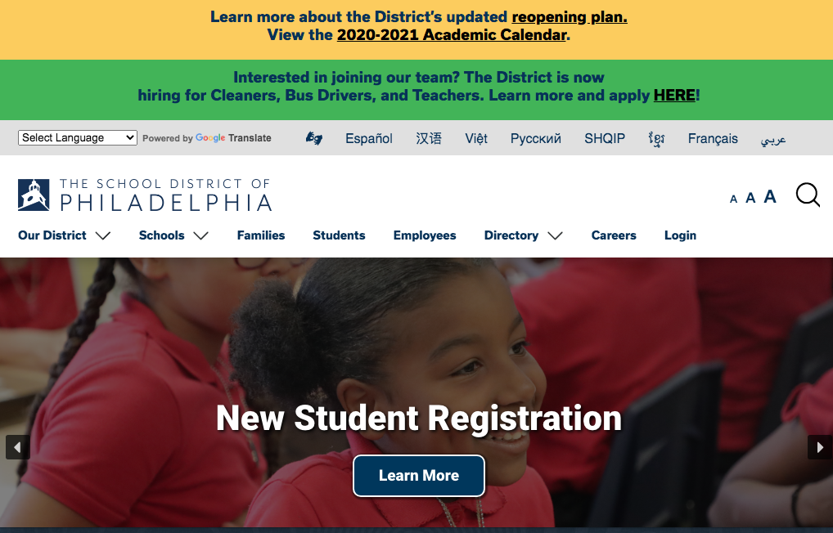
- Go to www.philasd.org and click on Login in the upper right.

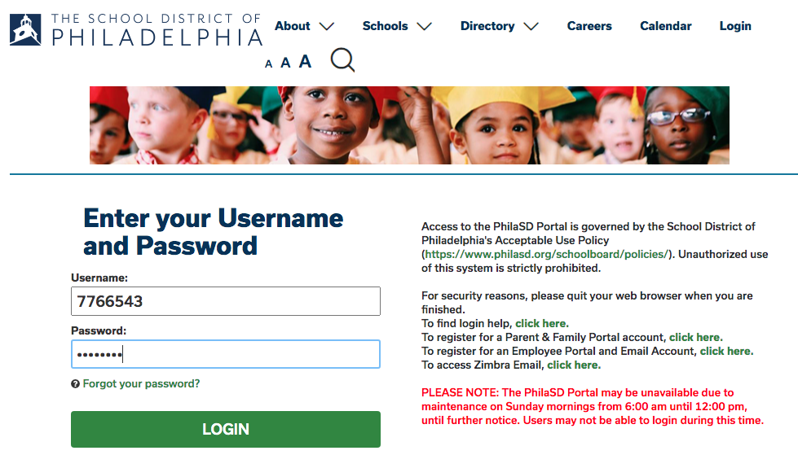
- Type in your student ID number and your password and click LOGIN
  - If you do not know your ID or need your password reset, email carnold@philasd.org with Password Help as the subject line.

- Click on the 3 lines in the upper left corner, the 6th option down is Schedule.

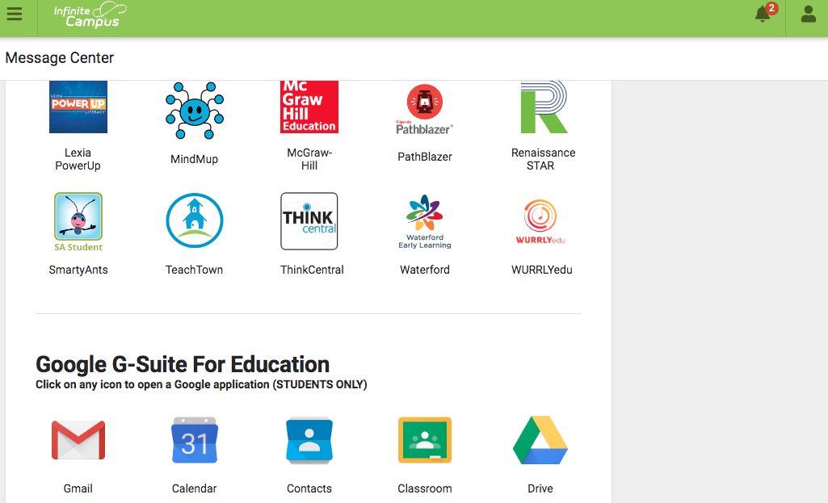
- The last or second to last option is Message Center. Click on that and scroll down until you see the Google menu and the Classroom icon.

- You will see several classes that you are enrolled in. When you click on a specific class, there will be a large colorful banner at the top with a link for your meets.

