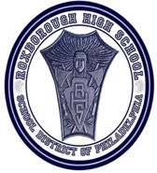

Tuesday, August 21st, 2018 (Last name A-L)

Thursday, August 23rd, 2018 (Last name M-Z)

9:00am-12:00pm

6498 Ridge Ave, Philadelphia, PA 19128

To RSVP and for more info contact

[carnold@philasd.org](mailto:carnold@philasd.org)

## Come and enjoy an exciting day with faculty, staff and students as you tour Philadelphia’s first All Academy High School, attend student workshops, and learn about all the programs we offer. Parents are strongly encouraged to attend. Workshops will be provided on various topics to support your child’s transition and academic success.

# FRESHMAN ACADEMY

# ACADEMY OF BUSINESS, TECHNOLOGY & ENTREPRENEURSHIP

# ACADEMY OF VISUAL ARTS PRODUCTION

# ACADEMY OF HEALTH SCIENCES & RESEARCH

Our Vision

The Academies at Roxborough High School develop strong college and career competencies that empower students to contribute to our global society.

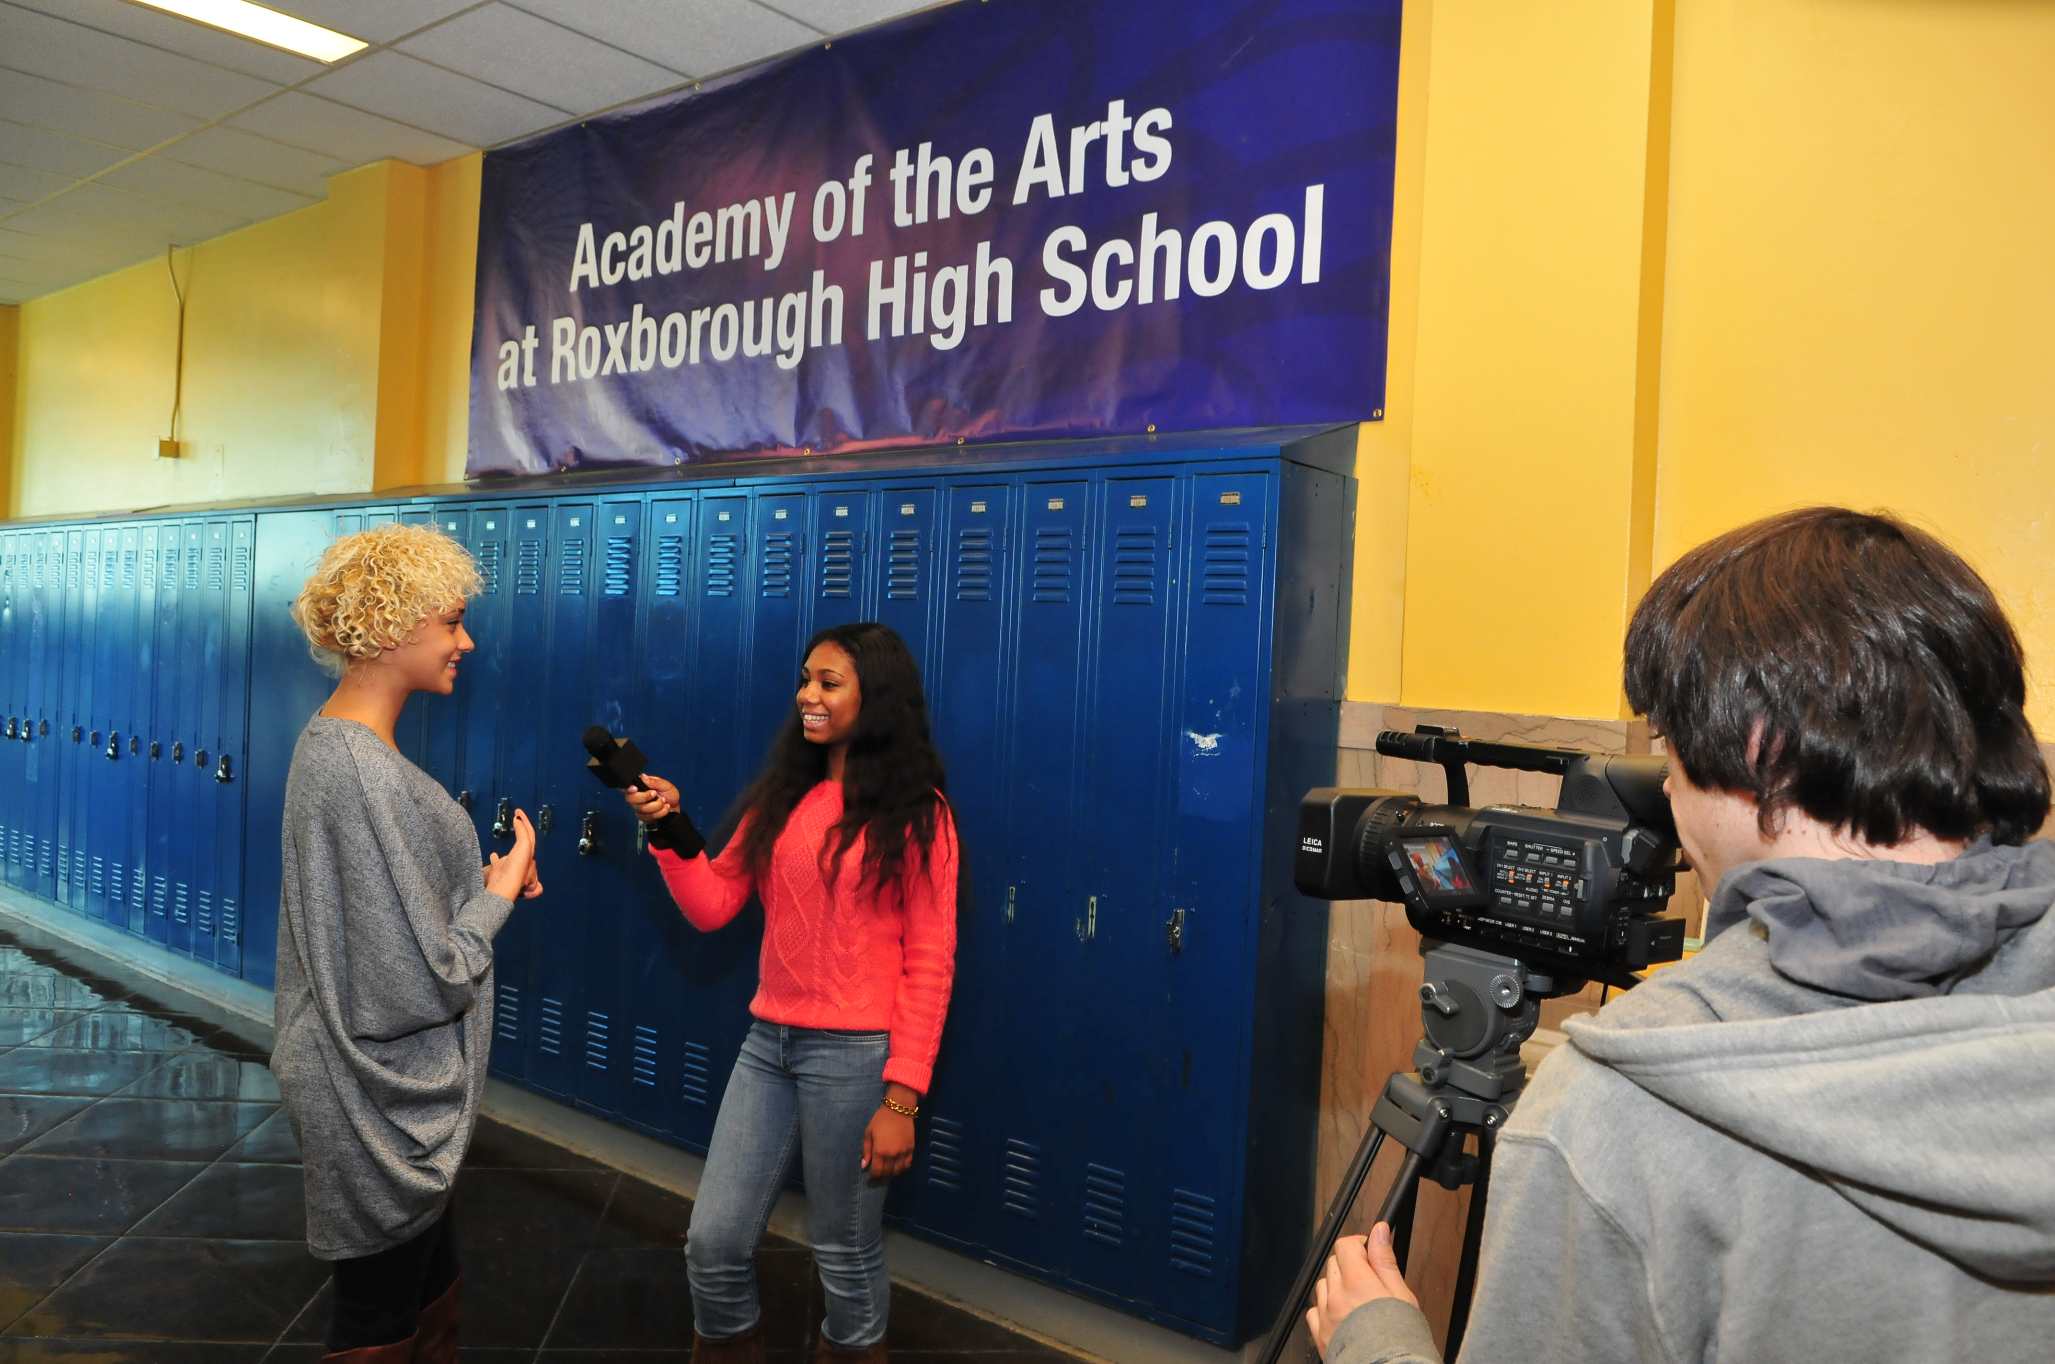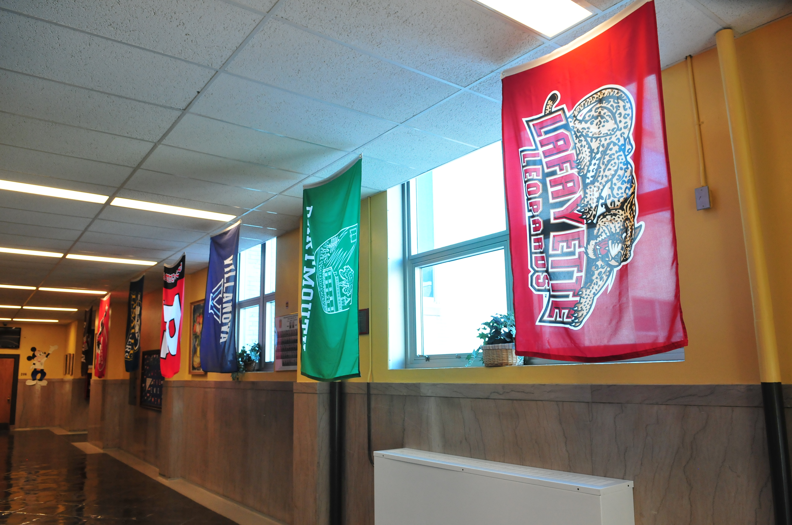

New Student Orientation 2018

The Academies at Roxborough

Welcome Class of 2022